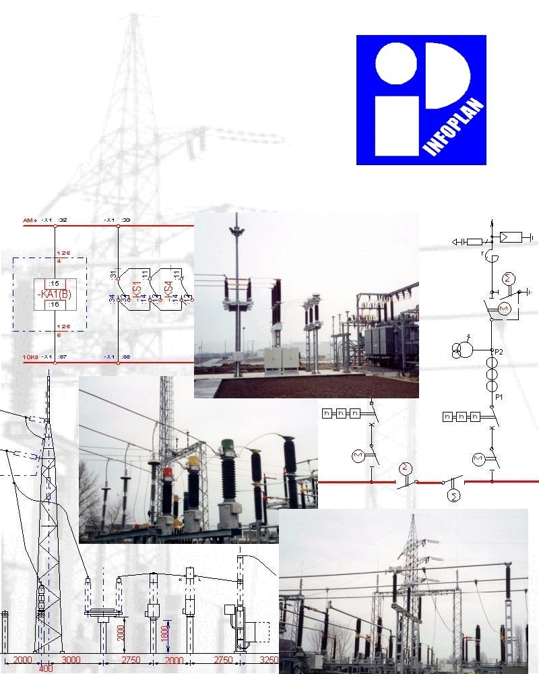

I n f o p l a n E n g i n e e r i n g L t d .


Informations…

Infoplan Ltd. is an independent engineering company, fully owned by Hungarian persons. This independency enables us to to be able to apply equipments made by any manufacturers, depending upon their proved quality or our costumers’ request.

Infoplan specializes in electric plans for mainly the power distribution companies, international as well as Hungarian companies.

We mostly design high voltage substations, but not only high voltage and middle voltage switchgears, but also low voltage equipment, power station systems and public or industrial distribution systems.

Infoplan is affiliated with customers from all over Hungary, as it is shown below:

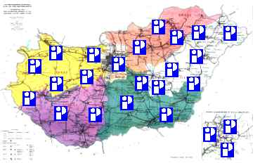

Eversince its foundation, Infoplan has been growing continously.
We have worked together with several subcontractors, hence we can undertake as a general designer for any projects upon request.

We have got a Certificate of Quality Insurance since December 1997 based on the requirements of ISO 9001, and ISO 14001 since January 2004.
Our experts’ expertise and their versatile command of technical back-ground in the offices have led to our permanent progress and financial stability.

We work and can meet our customers in our comfortable offices and our experts’ activity is helped by the latest office equipments including hardware and software alike.
The main office is in Budapest, and we have an office in Miskolc.

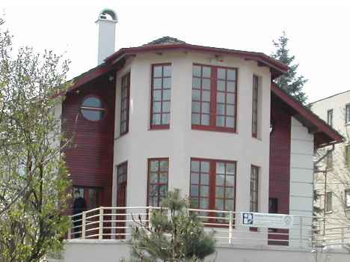

We assure our business partners to make optimal plans without any unnecessary extra expenses in the full length of the process applying our effective planning system.

We can guarantee high quality to our customers from initial step of signing a contract to the actual starting/opening of an establishment.

Our company is one of the most important Hungarian engineering organizations. We have professional experiences, expertise, special field-oriented knowledge and reference.

Fields of our activities…

Fields of our activities cover electric designing, general designing and engineering, as follows:

- Outdoor and indoor HV, MV installations,
- Civil works, lightning, heating, etc.
- Fire protection, and safety systems,
- Communications,
- Protections,
- Technical control systems.

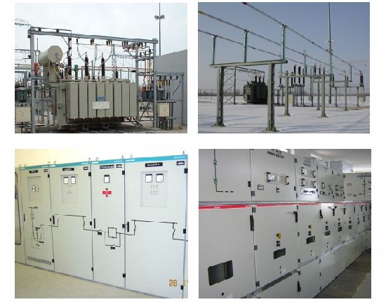

Engineering activities:

Expert activities:
- feasibility studies,
- test reports,
- technical analyses, consulting,
- planning control during the realization,
- focused consultations and education,
- renewable energy projects.

Tenders:
- tender specifications, including technical parameters,
- documentations for offers,
- technical evaluation of offers.
Technical documentations:

Our documentations are made following/harmonizing with the relevant laws and standards.

Parts of documentations:
- basic datas,
- technical subscriptions,
- drawings,
- material lists.

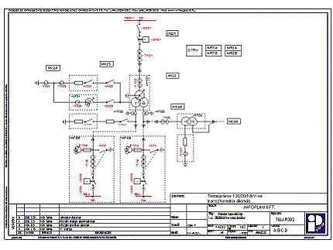
Levels of documentations:
- level „A”: study-report or plan for main technical data, and possible versions,
- level „B”: execution plans, including all technical informations for the contractor,
- level „C”: factory plans, including all technical information for the manufacturers,
- level „D”: as built plans.

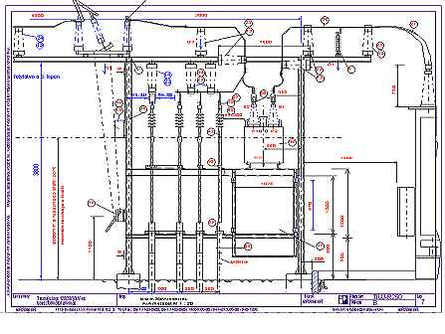
Our colleagues
and their authorities...

In Infoplan Ltd. the qualification requirements are prescribed for each position regarding not only the education or practical experience of our employees. These professional qualities mentioned above are justified by Chamber of Hungarian Engineers, the official authority for technical experts and leader of structural engineering.

Our leadership:

Lajos Kovács Technical Manager

Mr.Kovács is an authorized technical expert and leader of structural engineering, and is responsible for quality control.
From 1987 until 1992 he worked as a structural engineer in VERTESZ Company. He was commissioned to cooperate in a project for a year in Grenoble in Merlin Gerin.

Tibor Pázmándi Marketing Manager

Mr. Pázmándi is an authorised technical expert and leader of structural engineering.
He worked as an engineer in VERTESZ from 1981, From 1988 he headed the structural department, and was a member of a team to make type-plans for high-voltage substations in MVM Trust.

András Gábor Head of Primary Engineering

Zoltan Czetka Head of Secondary
Engineering

Our Certificates:

Our colleagues have the certificates for technical experts and leader of structural engineers required by the Chamber of Hungarian Engineers.

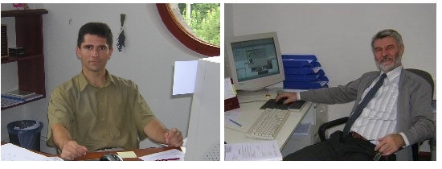

Our engineers all have university degrees and are professional at using the computer technology.

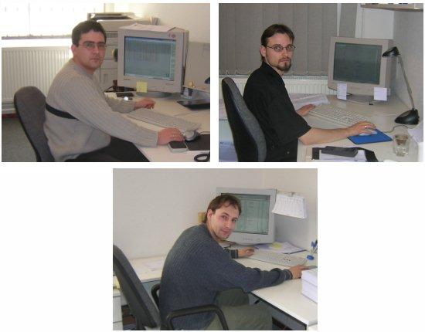

Based on written above, we have the fully ability and right to design the projects, which are mentioned in the field of our activities.

About some of our important projects…

In the course of the last ten years we have made several important and widespread projects. Some of our largest projects are the following.

Rózsakert substation in the territory of ELMŰ RT., 1997

In the last decade the Rózsakert substation project of 120/10kV has turned out to be one of the most important investments in ELMŰ substation program fully planned by Infoplan Ltd.

The view of the substation in a 3D picture.
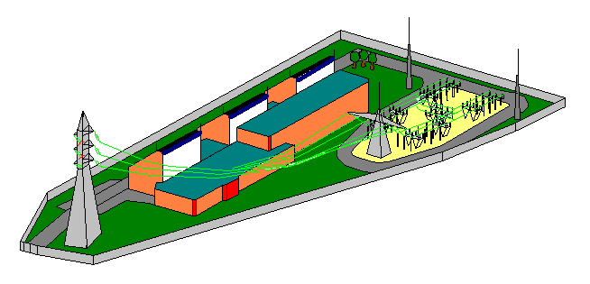

All the complete descriptions and drawings of primary and secondary electrical switchgear and controlgear, architectural constructions, fire-insurance, property-insurance, auxiliary and communications systems in this project plan were made by Infoplan Ltd. The official licencing procedure was made with our participation also.

Substation named Szultán utca in the territory of DÉMÁSZ RT., 2000

Szultán utca substation of 120/20/10kV was one of the largest transformer station in territory of Kecskemét.
As a general designer, Infoplan Ltd. made the complete constructural and electrical switchgear and controlgear plan-documentation.
Some photos…
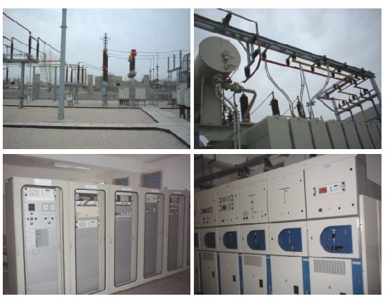

Typical plans, 2002-2003

Our very important project is the typical plan, which was made for E-On Hungária Rt. (DÉDÁSZ Rt., ÉDÁSZ Rt., TITÁSZ Rt.) and for DÉMÁSZ Rt.
The new substations during 2004-2005 was made partly or fully based on the typical plan:

- TITÁSZ Rt. Nyíregyháza-Kelet 120/10kV substation,
- DÉDÁSZ Rt. Pécs-Kelet 120/10kV substation,
- DÉDÁSZ Rt. Barcs 120/20kV substation,
- TITÁSZ Rt. Baktalórántháza 120/20kV substation.

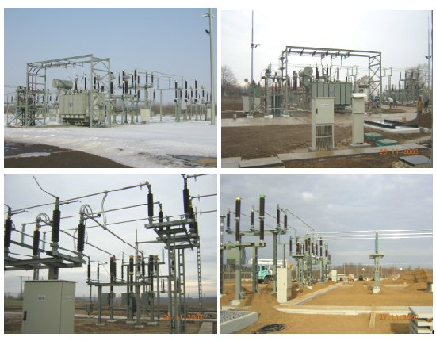
Additional references…


There are some further references in the following list without being complete.

Renewable energy

Infoplan has made feasibility studies, technical analyses and technical documentations for renewable energy projects, such as wind turbines in the area of Mezőtúr and Törökszentmiklós.



Digital equipment programming

We have take a part of programming and testing of digital equipments, such as protections of BKV M2 Metro project (Budapest), communication systems of industrial plants (Borsodchem, AUDI Győr etc.).

Green belt substation projects …

- Nyékládháza substation of 120/20 kV on territory of ÉMÁSZ Rt.,
- HAMA substation of 66/20/6.3/0.4 kV in Syria,
- Nádudvar substation of 120/20 kV in the territory of TITÁSZ Rt.,
- Visonta South coal-mine substation of 120/35/6kV in the territory of Mátra Powerstation Rt.,
- Hatvan substation of 120/20 kV on the premises of ÉMÁSZ Rt.,
- Komárom substation of 120/20 kV and Oroszlány substation of 120/35/20 kV in the territory of ÉDÁSZ Rt.

Examples from the reference list of our Hungarian customers of Electricity Works Co.

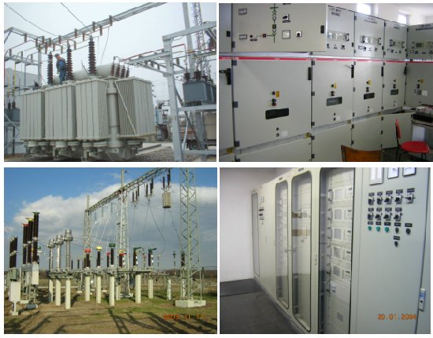

A lot of substation extensions…

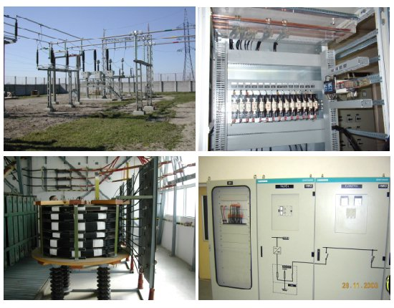

Other customers representing the processing industry …

- Tobacco factory in Eger,
- Lubricant factory of MOL Rt. in Komárom,
- Siemens Cable factory in Kistelek,
- Alföldi Porcelain factory.

Power stations as our customers …

- Mátra power station,
- Nyíregyháza power station,
- Debrecen power station.


Planning system...

Every element of Infoplan Ltd. planning documentations including the descriptions and drawings is produced by our complex computer planning system.

Format of these documentations meet the requirements prescribed in hungarian and international standards.

The application of this system in our document planning guarantees their accurate identification and registration, the ability to follow or control them, and, furthermore, means that our documentation is in correspondance with the relevant laws, rules or standards.

Using our own recording system results in avoiding losing any data, the ability of tracing any modifications or corrections made to the documents.

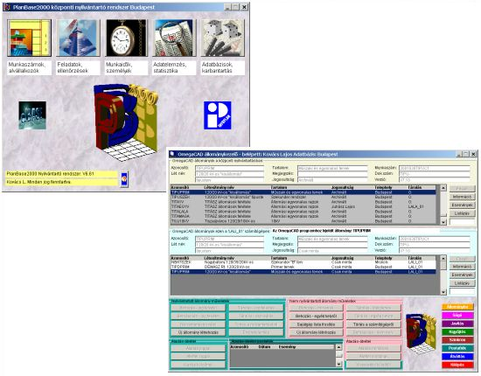

The unified system of documentation provides the required quality, the uniformed format and easy handling for either all of our customers or our colleagues too.

On the basis of our information got them during our international activies we can declare that quality of our planning dokumentations and planning system are equivalant to the products of the best engineering offices in the world.

The drawings are made by software system of OmegaCAD Elektro, the materials or I/O lists are made by own software system of dBASE, and the further documents are made by programs of MS-Office for PC.

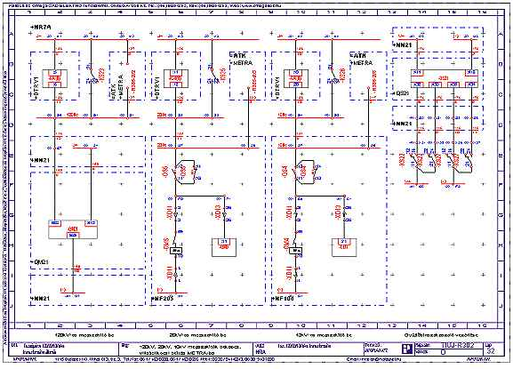

These planning programs using our enternet computer síystems provides making a high quality dokumentation without any practical mistakes appeared using the traditional/manual planning, drawing system. These modern planning systems use automatical analysing data-collecting, testing, generating moduls therefore these can operate without pssibility of any traditional and typical manual planning mistakes.

Handing over of our planning dokumentations is possyble traditionally on papers and/or as a CD ROM. In this case our customers can store their complete documentation in their own computer system.

Technical devices...

There has been opereting an enternet computer system with high reliability among our office-rooms for many years. Consequently we can hanling the planning data rather safetly.
It is only too natural we expend care on maintenance and development og our technical instruments continuously.

Hardwares:

The central part of our enternet computer system is a high power Linux-based server computer on each plant, with laser and color printers, and an on-line connection between the offices.
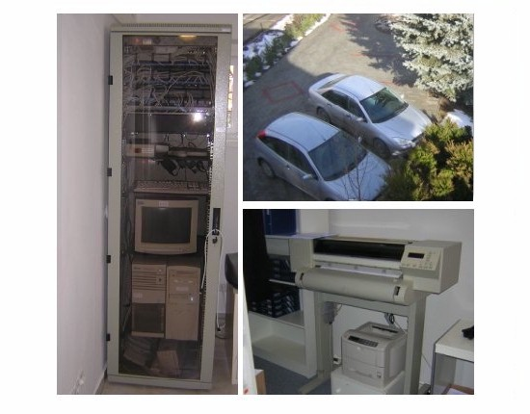
Our terminals are up to date high speed PC with parameters according to the requirements of modern labour hygiane.

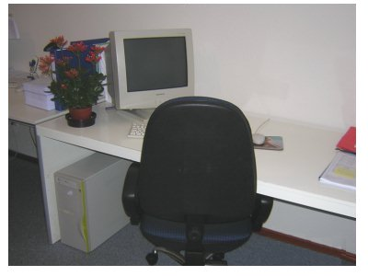
Other technical devices:
- plotters and printers,
- high power photocopy devices,
- ISDN phone center and fax,
- internet with high speed comunication,
- video devices.

Softwares:

Our documents are made with all of softwares by right indeed.
There is used Windows NT and XP operation system on our enternet (Microsoft Open License No.11374113).
The basis of our planning system is the 12 copies of

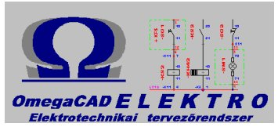
developed in Hungary according to the relevant rules and standards and to the requirement of our customers.

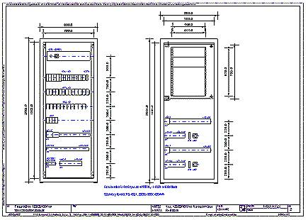

The other softwares using to produce our dokumentations are the followings:
- Microsoft Office applications,
- Data-handling programs used Borland Visual dBASE and C++Builder developed for own purposes by Infoplan Ltd.

Quality system…


The parts of the system are the followings:
- Quality management systems
ISO 9001:2000,
- Environmental management systems ISO 14001:2004,
- Occupational health and safety management systems
OHSAS 18001:1999,
- Information technology, information security management
ISO/IEC 17799:2005.

The first successful ISO 9001 audit was at 1997. and ISO 14001 at 2004. declared on Certificate by MSZT TT (Hungarian Standard Institution). During the normal procedure we were succesful to get the Certificates again.

Reg.number: 503/0121(3) and KIR/85(1) MSZT TT

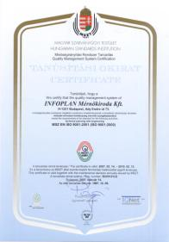

All of our subcontractors and supliers are prequalifying by Infoplan Ltd. to provide the high and permanent level of quality in our dokumentations, according to our declaration of our System Handbook.

Thus System Handbook is the basis of our quality insurance system and it is accessibele to our customers indeed. The results of our activity in our quality insurance system are providing the maintenance and if it is possible increasing the high technical level of our documentations continuously and in the other case taking care of the quality of equipment and devices applied in our plans with proving of the type test reports carried out on reqvests of the relevant standards.



According to the requirements of our quality insurance system all printed or diditalyzed documents made by own or partners of Infoplan are systematized to provide the documentation totally.

During the procedure of planning all the documents are tested continuously.

During the execution our engineers follow with attantion the planned objects to insuring the quality in practice.

The Infoplan Engineering Office Ltd. is ready to setisfy all the engineering requests of the customers like investors, manufacturers technician and operating partners with of its professional activities.

Infoplan Engineering Ltd.  H-1221 Budapest Ady Endre str. 73.  Tel: (+36-1) 424-6500, Fax: (+36-1) 424-6510  E-mail: infoplan@infoplan.hu |  | Company informations.  Made by: Kovács Lajos  Doc. No.: IP-REF-043/C  Budapest, april 23. 2007.

